**Project Initialization and Planning Phase**

|  |  |
| --- | --- |
| Date | 15 March 2024 |
| Team ID | xxxxxx |
| Project Name | xxxxxx |
| Maximum Marks | 3 Marks |

**Define Problem Statements (Customer Problem Statement Template):**

Chronic Kidney Disease (CKD) is a progressive condition characterized by a gradual loss of kidney function over time. If left untreated, CKD can lead to end-stage renal disease, requiring dialysis or kidney transplantation, and significantly impacting the quality of life. Early detection and intervention are crucial in slowing the progression of CKD, reducing the risk of complications, and improving patient outcomes. However, early stages of CKD often present with subtle or non-specific symptoms, making timely diagnosis challenging.

**Example:**

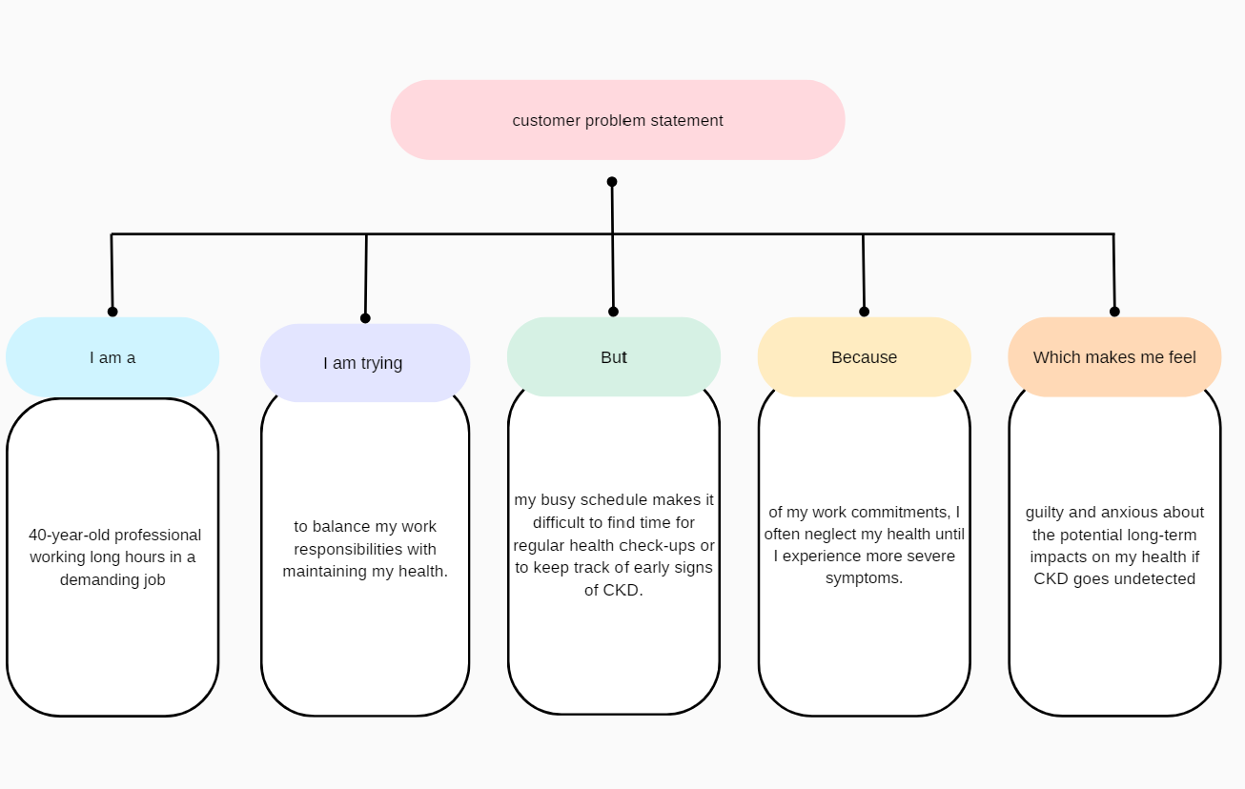

|  |  |  |  |  |  |
| --- | --- | --- | --- | --- | --- |
| **Problem**  **Statement**  **(PS)** | **I am**  **(Customer)** | **I’m trying to** | **But** | **Because** | **Which makes me feel** |
| PS-1 | a 40-year-old professional working long hours in a demanding job | to balance my work responsibilities with maintaining my health | my busy schedule makes it difficult to find time for regular health check-ups or to keep track of early signs of CKD. | of my work commitments, I often neglect my health until I experience more severe symptoms. | guilty and anxious about the potential long-term impacts on my health if CKD goes undetected |
| PS-2 | a 60-year-old individual with a history of diabetes and hypertension. | to keep track of my health and manage my chronic conditions effectively. | it's challenging to monitor all the necessary health parameters and recognize early signs of CKD without frequent doctor visits. | of the complexity of managing multiple health conditions, I often feel overwhelmed and unsure if I am doing enough to stay healthy. | stressed and concerned about the possibility of developing CKD without noticing it early enough for effective treatment. |